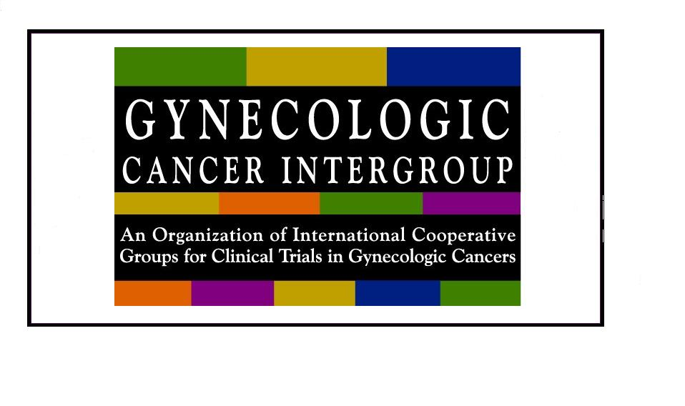 v. Aug 2018
GCIG Harmonization Committee Representative
Travel Support Application
GCIG will award a travel grant for one non-clinical harmonization committee delegate (Ops or Stats) per GCIG member group to attend a GCIG meeting once per calendar year. Applications must be submitted at least 3 months prior to the meeting. Economy (lowest fare) travel bookings are expected. Requests will be assessed and travel grants will be awarded on a case-by-case basis. Applicants will be notified of approval (or not) within one month of receipt of application.
Amount limits: 1000.CAD for North American & European attendees to N. America & Europe; $2000.CAD for Australasia attendees to N. America & Europe; vice versa for attendance in Australasia.
Eligibility:
- Non-Clinician delegate (statistician, operations, data manager);
- Attending/registered harmonization delegate representing a dues-paying GCIG member group; NOT reimbursed if claimant does not in fact attend Harmonization meetings.
- Submit receipts, travel tickets and boarding passes (for air travel) with completed GCIG Expense Claim Form within one month after attendance.

Please complete and return the form to GCIG Operations at:
gcigopsasst@gmail.com

Applicant Information:
Name & role: | GCIG Member Group:
Email: | Phone number:
Address:

Request:
Date of GCIG Meeting:

Amount Requested:

